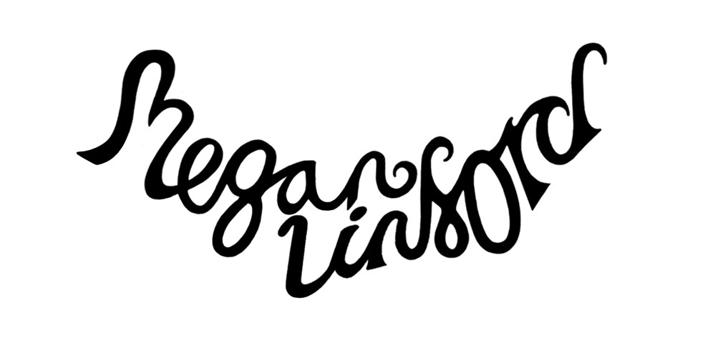

Emerging Folk-Roots Artist, Megan Linford, is making her way on the UK Folk/Indie scene with her ‘70’s tinged Song writing and Traditional inspired melodies. Drawing inspiration from the Earth, she notates the rhythm and pulse of everyday life through her songs. Dipping in and out of Dark-Folk, Americana and with hints at Gospel/Soul; Megan’s music spans genres. A regular on the Souths gigging and Festival Circuit, Receiving the
Sussex Young Folk Performer award in 2014 at 17 and going on to support folk artists such as; The Oyster Band, Flossie Malavialle, Martha Tilston, Luke Concannon (Nizlopi) and BBC 2 Young Folk Award winners Ciaran Algar and Greg Russell. As an independent and DIY artist, Megan has been self-releasing since the beginning, a one woman force to be reckoned with. Megan received Best Soloist at 2019 Portsmouth Guide Awards - Runner Up 2020. In 2019 Megan bagged support slots for Emily Barker and Marry Waterson at The Wedgewood Rooms, New York based Olden Yolk and Dan Bettridge at Sebright Arms. Megan dropped the first two tracks from her debut album in 2019, an album with a story that leads you through the seasons of the year. With a Winter headline tour in London/Manchester and an acoustic tour in April to follow Megan is making waves on the UK Music scene.

An ACM Graduate; Driven by her passion and love for music and song writing; Megan’s a free spirit with a love for creating and connecting with audiences. Megan started her own Folk night summer of 2018 in Portsmouth to fill the ever-growing gap in the city for Folk/Bluegrass/Americana. The night has been a huge success and has seen bands from as far as North Carolina come to play. Megan funds her music working as an Acoustic Guitar specialist in the music store, PMT Portsmouth. Three and a half years of industry experience and guitar tech skills have given Megan a great deal towards her music career.

Past Venues
The Wedgewood Rooms, Portsmouth
The Boilerroom, Guildford
Spiritual Bar, Camden
Alexandra Theatre, Bognor Regis
Café Setup, Ternat - Belgium
The Ritzy, London
Sebright Arms, London
The Star Inn, Guildford
The Talking Heads, Southampton
The Brunswick, Brighton
Spice of Life, London
Whiskey Jar, Manchester
The Platform Tavern, Southampton
The Dolphin, Littlehampton
The Chichester Inn, Chichester
Warwick St Social, Norwich
The Square Tower, Portsmouth
Langhams Brewery, Petworth
Liphook Folk Club, Liphook Social Club
The Eagle Inn, Arundel
Alleycat, London
Staggeringly Good, Portsmouth
Lantern Theatre, Mountbatten School - Romsey
The Wave Maiden, Portsmouth
Petersfield Festival Hall
The Lucky Pig, London
The Square Brewery, Petersfield
The Good Intent, Petersfield
Wessex Folk Festival
Trinity Folk Festival
Beggars Fair Festival
Southdowns Folk Festival
Haslemere Fringe Festival
Weyfest
Arlesford Festival
Victorious Festival
Wickham Festival
Middlewich Folk and Boat Festival
Close To the Sun Fest
Petersield Beer/Spring/Summer Festivals
Dials Festival
Icebreaker Festival

